WHO ARE WE?

(Zhuangzi didn't know if he was Zhuangzi who had dreamt
he was a butterfly, or a butterfly dreaming he was Zhuangzi)

Some say it was the trees that dreamt us up,
Hallucinations from a shaman’s cup.
Others, to wake us from our reveries,
Propounded there are infinite galaxies
Through which, gypsy-like, our fathomless mind
Is travelling since beginningless time;
Changing, effecting, causing, adapting,
Momentarily existing, no thing.
Replacing, confounding, a mystery
Expanding, now contracting, for ever.

We spin through space at a thousand miles an hour
Whilst mortality cheats the ivory tower;
Hurtling towards death on a water-rock
The end, when it comes, a short, sharp shock.

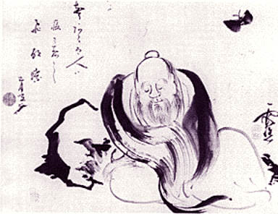

Stuart Benton

